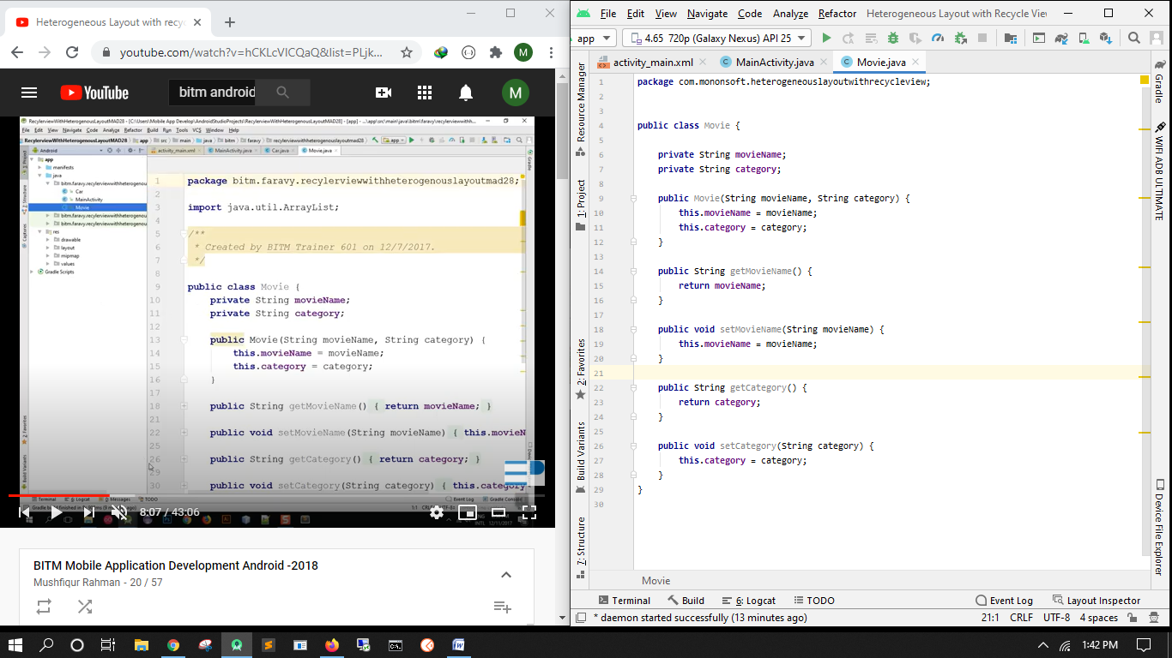

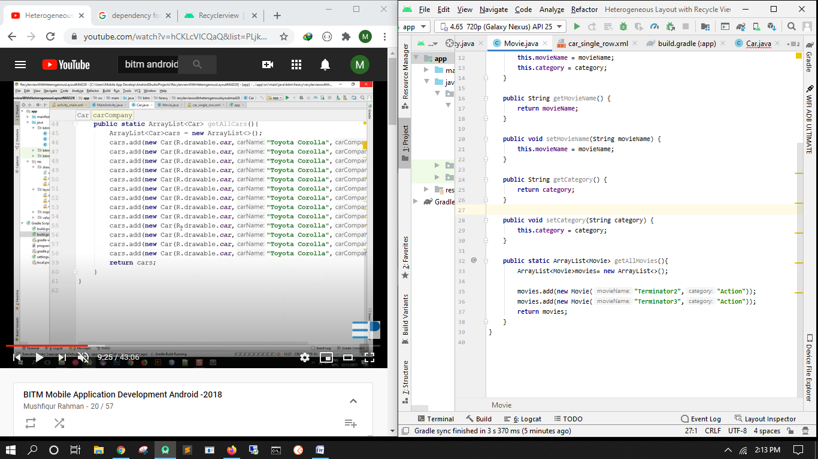

Car image download  
paste it in drawable

In buid gradle= sync it

implementation "androidx.recyclerview:recyclerview:1.1.0"

implementation "androidx.cardview:cardview:1.0.0"

New layout- car_single_row

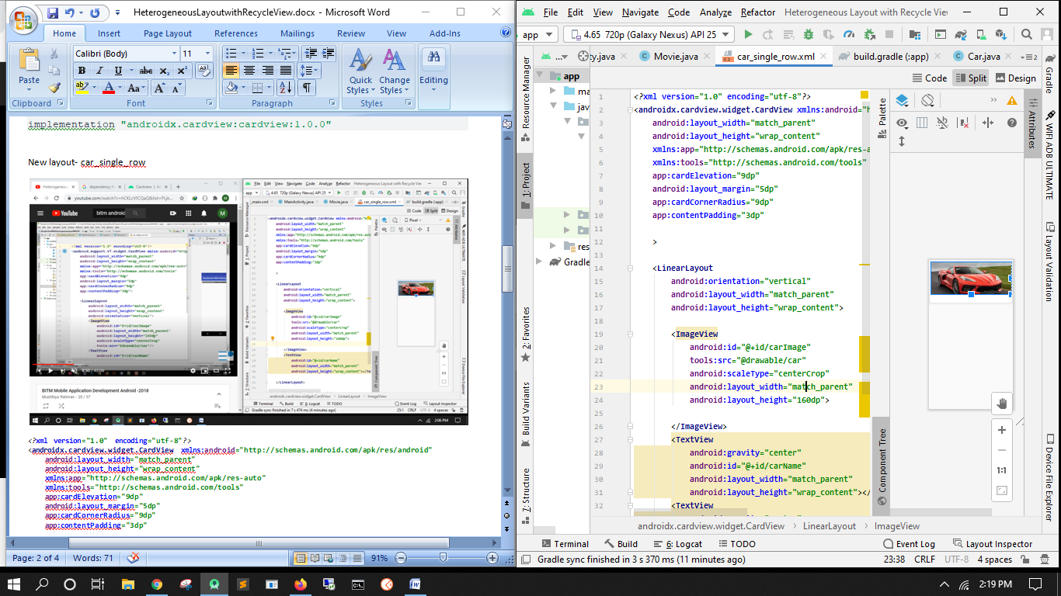

*<?***xml version="1.0" encoding="utf-8"***?>*<**androidx.cardview.widget.CardView xmlns:android="http://schemas.android.com/apk/res/android"  
 android:layout_width="match_parent"  
 android:layout_height="wrap_content"  
 xmlns:app="http://schemas.android.com/apk/res-auto"  
 xmlns:tools="http://schemas.android.com/tools"  
 app:cardElevation="9dp"  
 android:layout_margin="5dp"  
 app:cardCornerRadius="9dp"  
 app:contentPadding="3dp"** >  
  
 <**LinearLayout  
 android:orientation="vertical"  
 android:layout_width="match_parent"  
 android:layout_height="wrap_content"**>  
  
 <**ImageView  
 android:id="@+id/carImage"  
 tools:src="@drawable/car"  
 android:scaleType="centerCrop"  
 android:layout_width="match_parent"  
 android:layout_height="160dp"**>  
  
 </**ImageView**>  
 <**TextView  
 android:gravity="center"  
 android:id="@+id/carName"  
 android:layout_width="match_parent"  
 android:layout_height="wrap_content"**></**TextView**>  
 <**TextView  
 android:gravity="center"  
 android:id="@+id/carCompany"  
 android:layout_width="match_parent"  
 android:layout_height="wrap_content"**></**TextView**>  
  
 </**LinearLayout**>  
  
</**androidx.cardview.widget.CardView**>

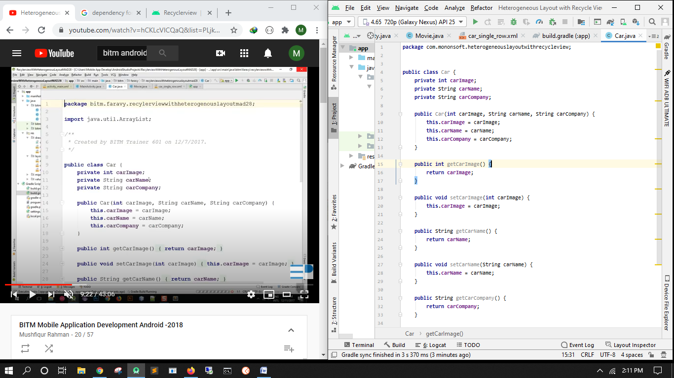

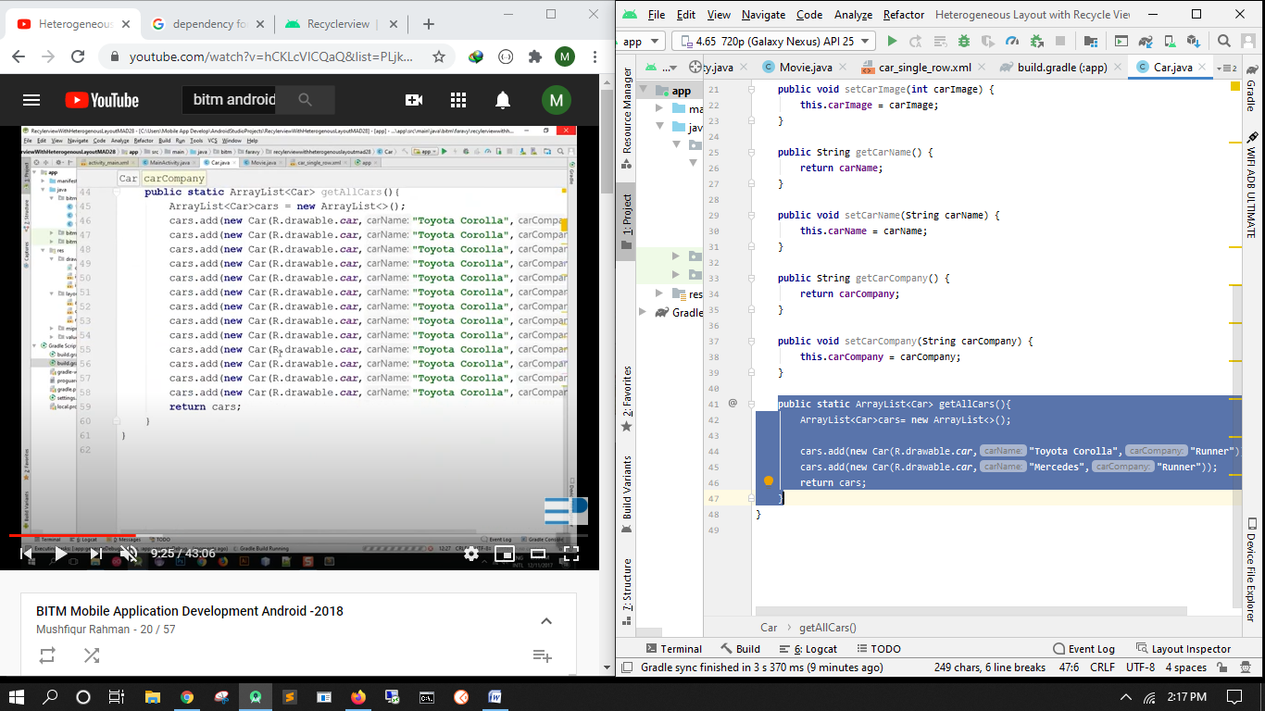

**public static** ArrayList<Car> getAllCars(){  
 ArrayList<Car>cars= **new** ArrayList<>();  
  
 cars.add(**new** Car(R.drawable.***car***,**"Toyota Corolla"**,**"Runner"**));  
 cars.add(**new** Car(R.drawable.***car***,**"Mercedes"**,**"Runner"**));  
 **return** cars;  
}

new layout- movie_single_row

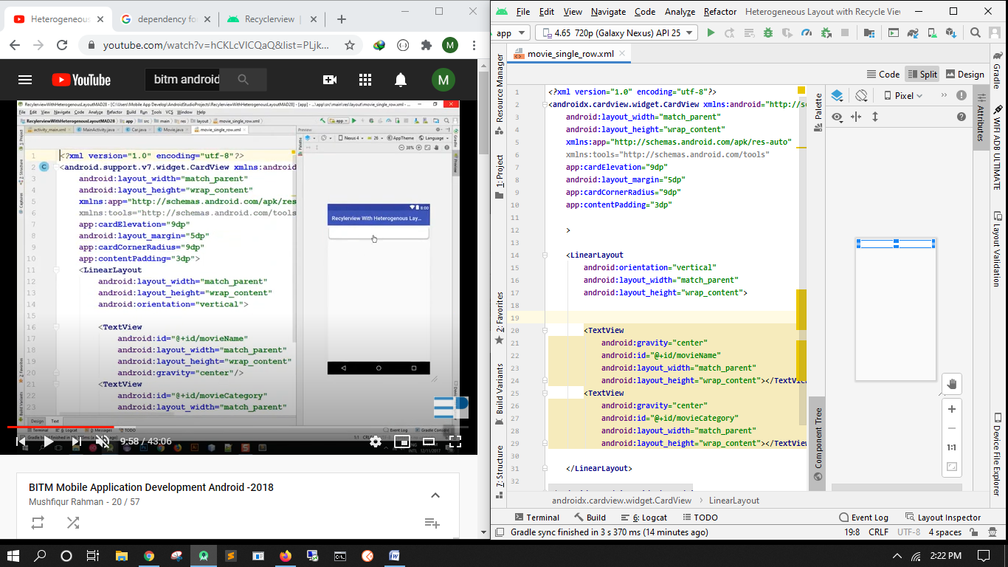

*<?***xml version="1.0" encoding="utf-8"***?>*<**androidx.cardview.widget.CardView xmlns:android="http://schemas.android.com/apk/res/android"  
 android:layout_width="match_parent"  
 android:layout_height="wrap_content"  
 xmlns:app="http://schemas.android.com/apk/res-auto"  
 xmlns:tools="http://schemas.android.com/tools"  
 app:cardElevation="9dp"  
 android:layout_margin="5dp"  
 app:cardCornerRadius="9dp"  
 app:contentPadding="3dp"** >  
  
 <**LinearLayout  
 android:orientation="vertical"  
 android:layout_width="match_parent"  
 android:layout_height="wrap_content"**>  
  
   
 <**TextView  
 android:gravity="center"  
 android:id="@+id/movieName"  
 android:layout_width="match_parent"  
 android:layout_height="wrap_content"**></**TextView**>  
 <**TextView  
 android:gravity="center"  
 android:id="@+id/movieCategory"  
 android:layout_width="match_parent"  
 android:layout_height="wrap_content"**></**TextView**>  
  
 </**LinearLayout**>  
  
</**androidx.cardview.widget.CardView**>

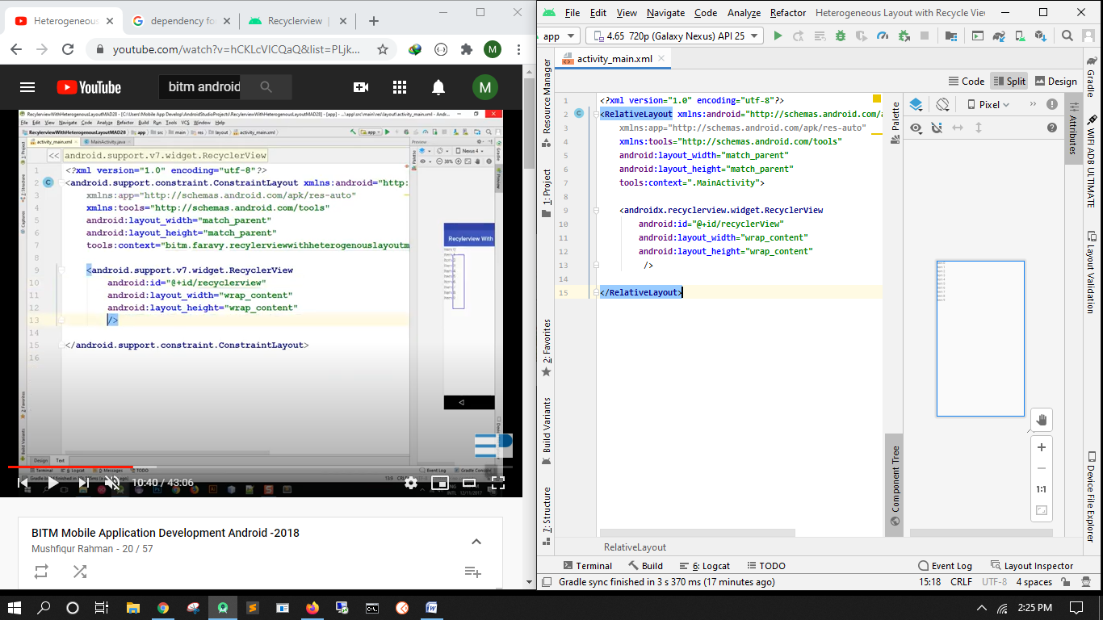

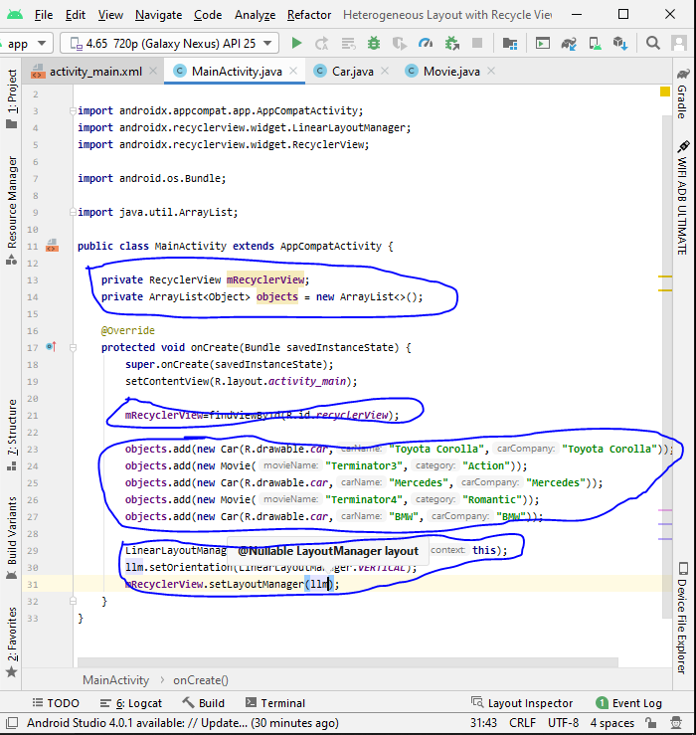

Create new class- ObjectAdapter

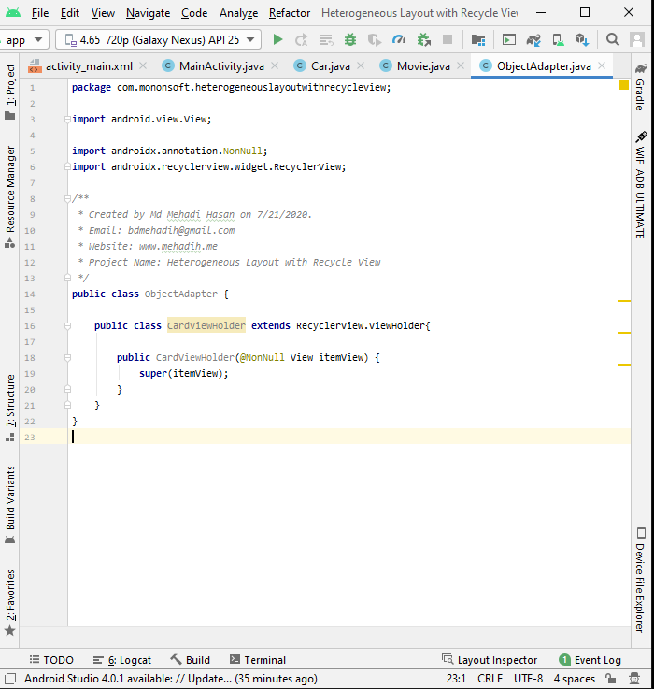

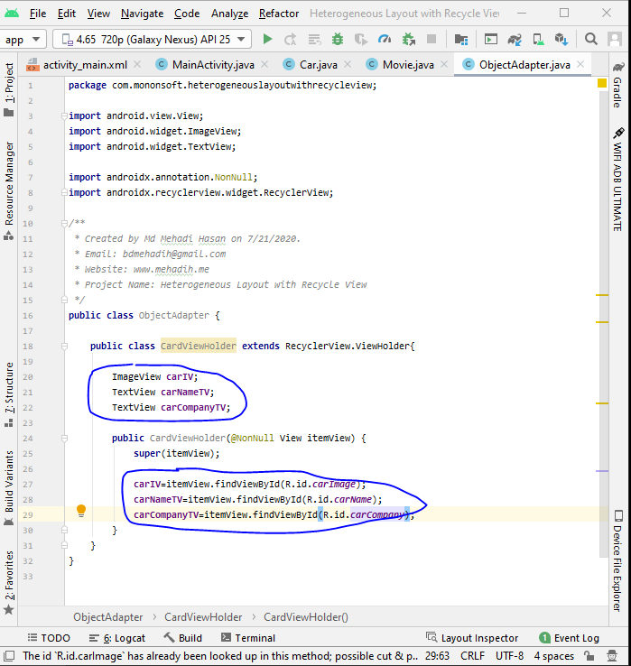

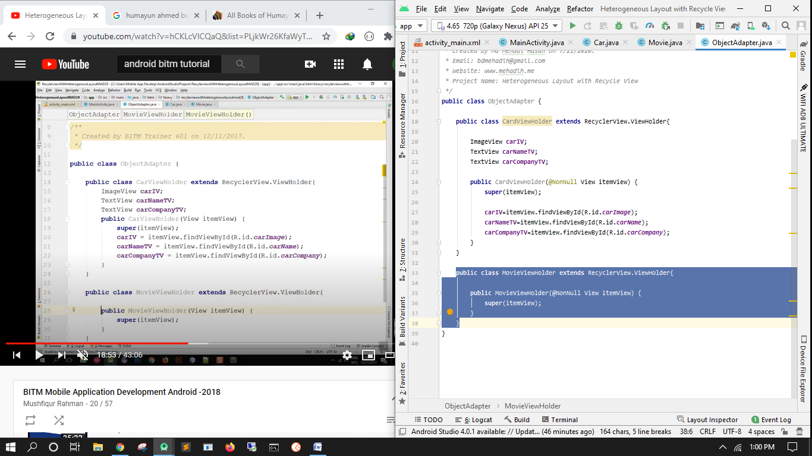

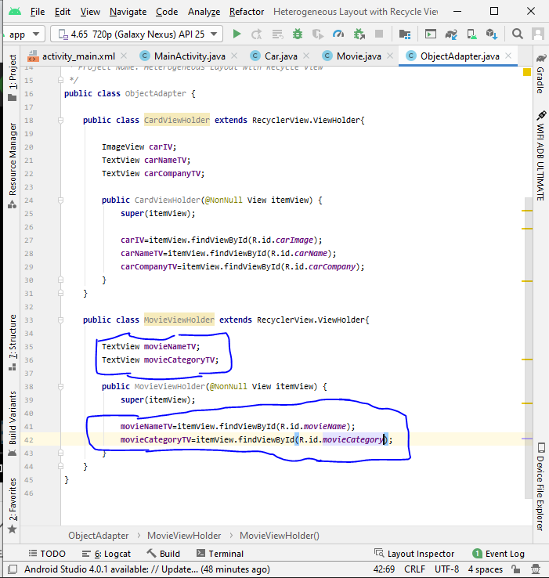

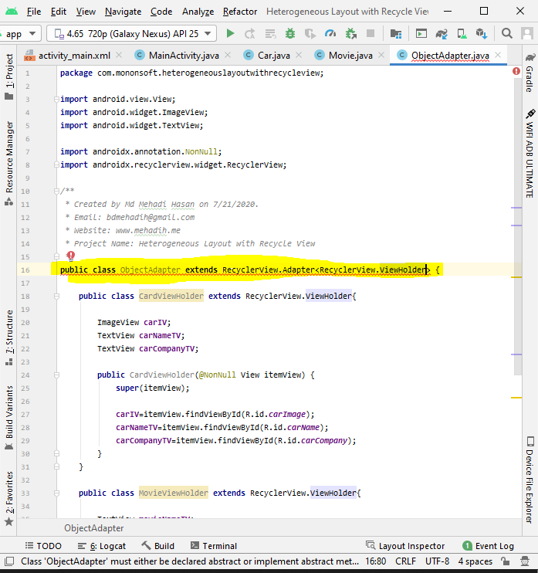

Alt+ent

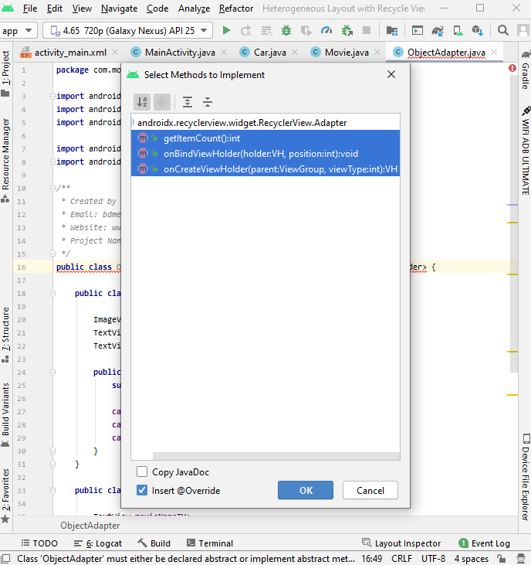

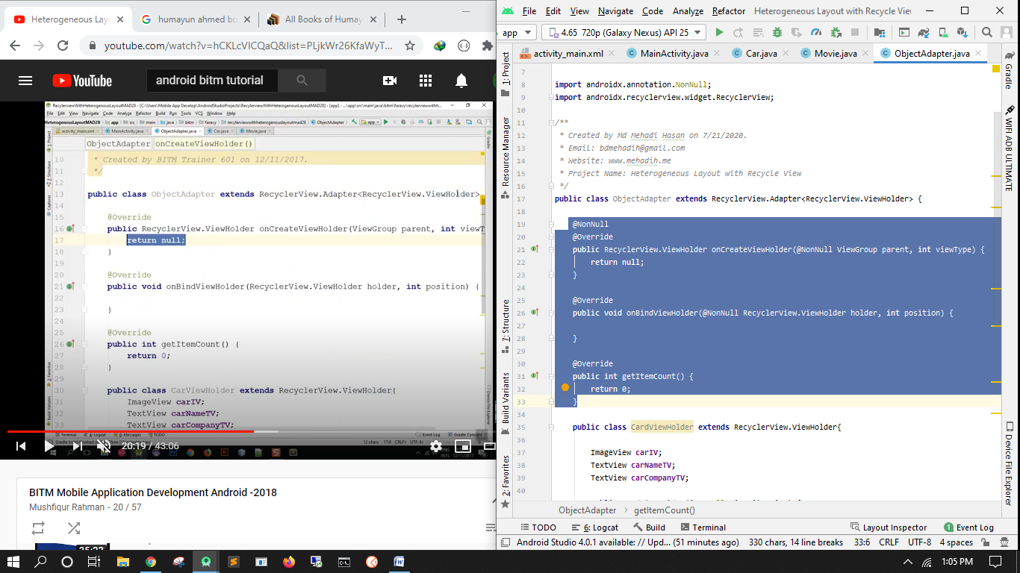

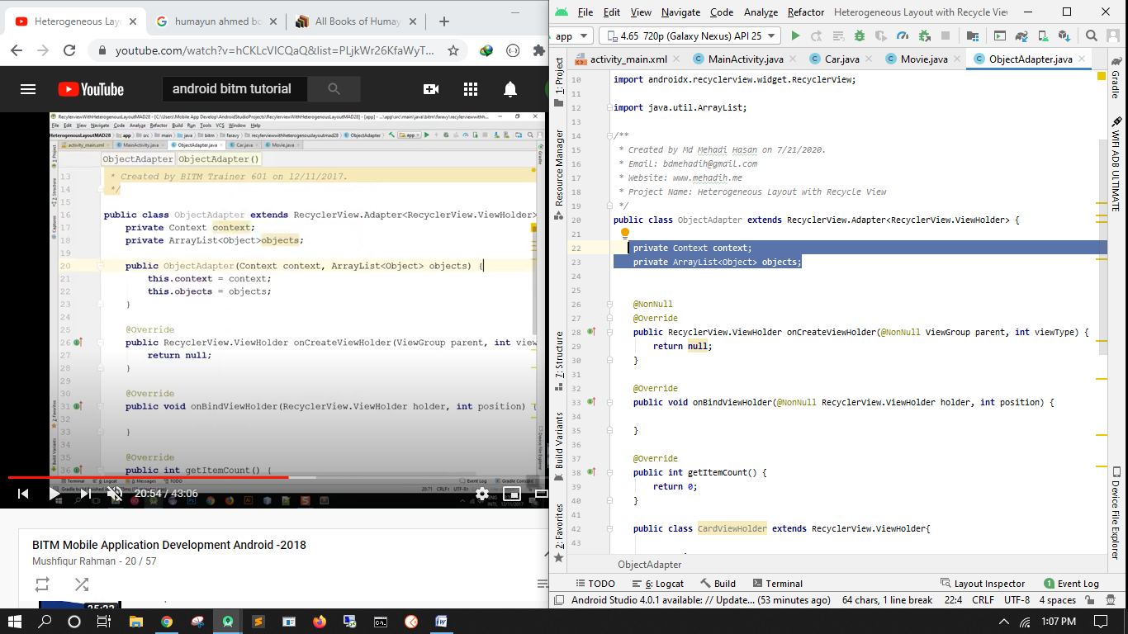

Create constructor

